VISIT BERWICKSHIRE COAST
THE COASTAL JOURNEY
DAY 1- Burnmouth & Ayton
Start your journey at the border line and stand in two nations at one time. Follow the A1 north for just 5 mins before you reach the village of Burnmouth nestled in the hills. Here is a quaint and charming village with a small harbour.
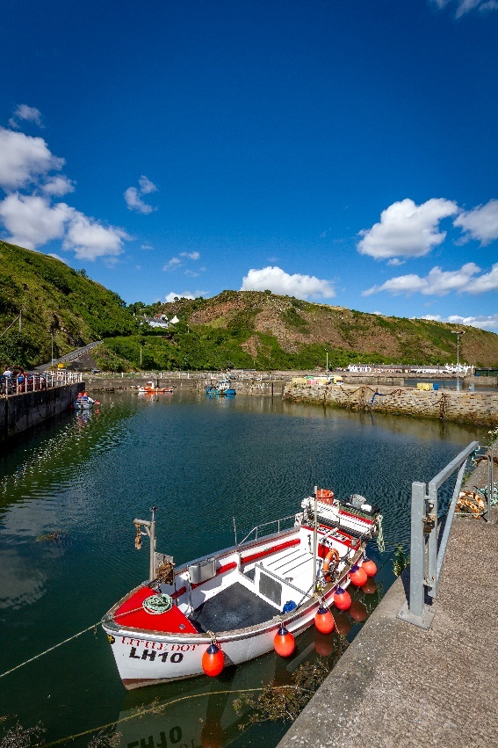
From here continue along the A1 to your next stopping point of Ayton, where you can walk the grounds of an important Scottish Baronial castle. Finish your evening at the Hemelvaart Bier Café for a drink or live music.
DAY 2- Eyemouth
Head off to Eyemouth the largest town in the region, choose between discovering the Smuggler’s history at Gunsgreen House or the local fishing and social heritage at Eyemouth Museum
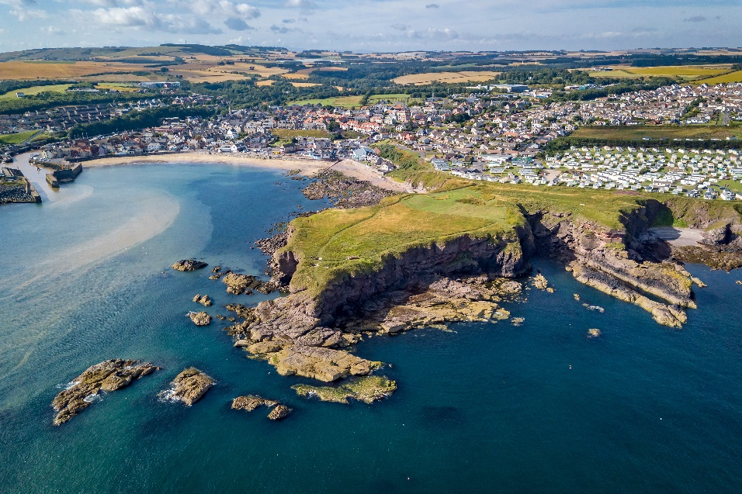
Make sure you fit in time for lunch as Eyemouth’s award-winning fish & chips is not one to miss!
Take a boat trip out and around the coastline to see the true beauty of the coast. You might see some dolphins along the way! Or stay around the harbour and beach to watch the seals and try the incredible ice cream with flavours like, Coconut & Mango or Jammie Dodger.

DAY 3- Coldingham
Move on to Coldingham and dip your feet on the award-winning beach.
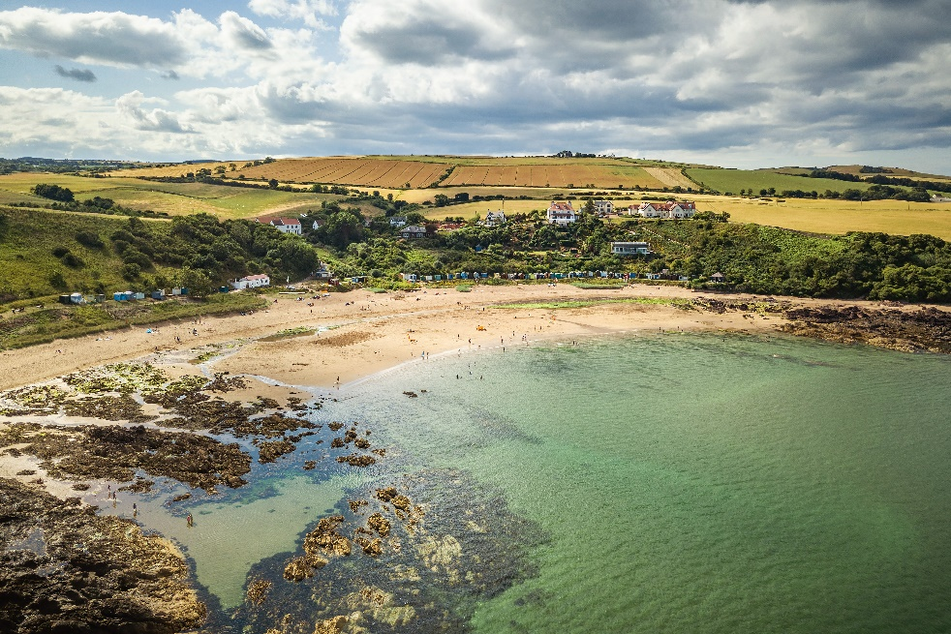
Take time to visit Coldingham Priory
DAY 4- St Abbs
St Abbs is plentiful in specular nature and sites. Get up look to the ‘Seabird City’ which echoing. See the clear waters of a foreign land.
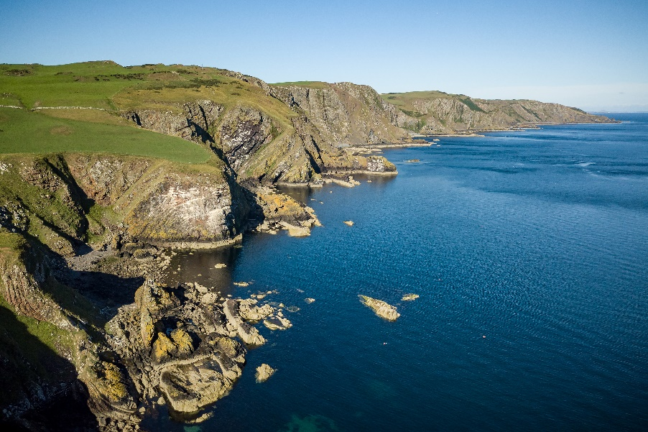
Stop for lunch in one of the restaurants for your taste of true Scottish seafood.

DAY 5-Siccar Point, Pease Bay
Walk along the stunning Berwickshire Coastal Path, taking in the stunning views and nature.
Stop by the world-famous, Siccar Point, the most important unconformity described by James Hutton which changed the world’s ideas on the origin and age of the Earth. See if you can find St Helen’s Church as you head up to Cove

Itineraries
The Berwickshire Coast Path
Day 1- Start your journey at the

History & Heritage
AM- Start of your day in Eyemouth Museum learn all about town history and culture of farming, agriculture etc.

Geology Trail

Smugglers Trail

Sea Lover Trip
Day 1- Dive
Day 2- Surfing
Day 3- Fishing
Day 4- Rib Trips

Nature Lover

